Size-Weight illusion Demo
We have two boxes; each contained a mass of 1 kg. The task is to judge which one is heavier (lighter or the same). The small one is 3x3x4 inches and 5.5x5.5x6.
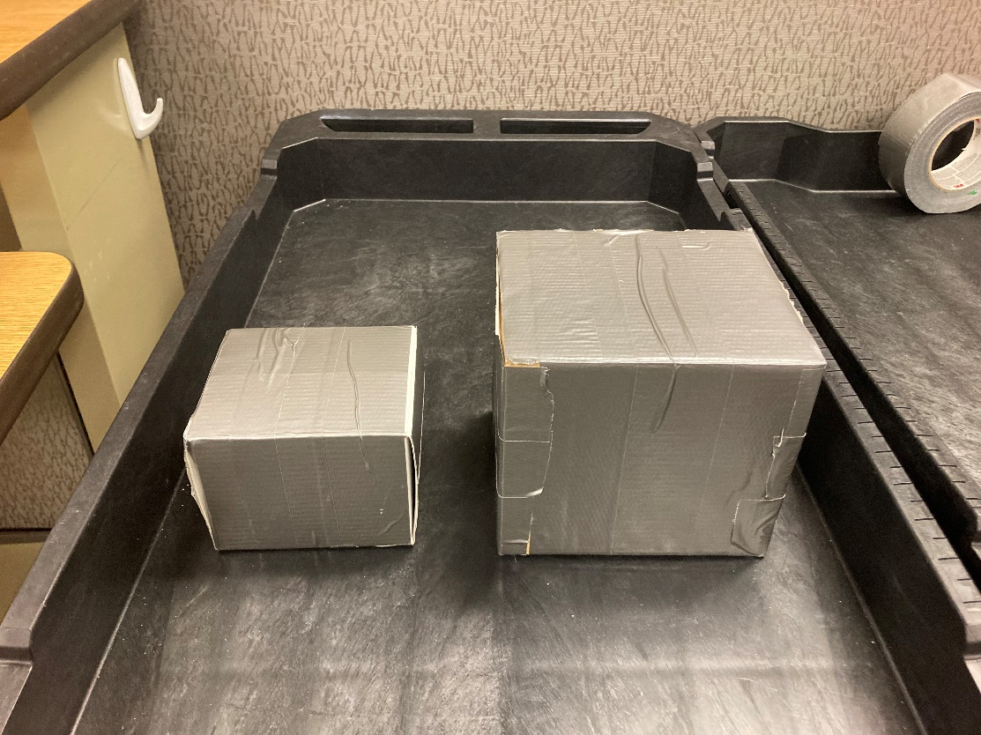

What’s your prediction about the perceived weight of each?
_________________________________________________________________________________________________
_________________________________________________________________________________________________
_________________________________________________________________________________________________
What was the actual judgment?
_________________________________________________________________________________________________
_________________________________________________________________________________________________
_________________________________________________________________________________________________
Heaviness perception experiment – the testing moment of inertia hypothesis
You will be given two aluminum rods. We will explore a psychophysical method of adjustment to explore when your perception of the heaviness of the rods is similar. Details of the procedure are in Turvey’s (1996) Dynamic Touch article.
Picture of the reference rod: Red arrow – position for holding
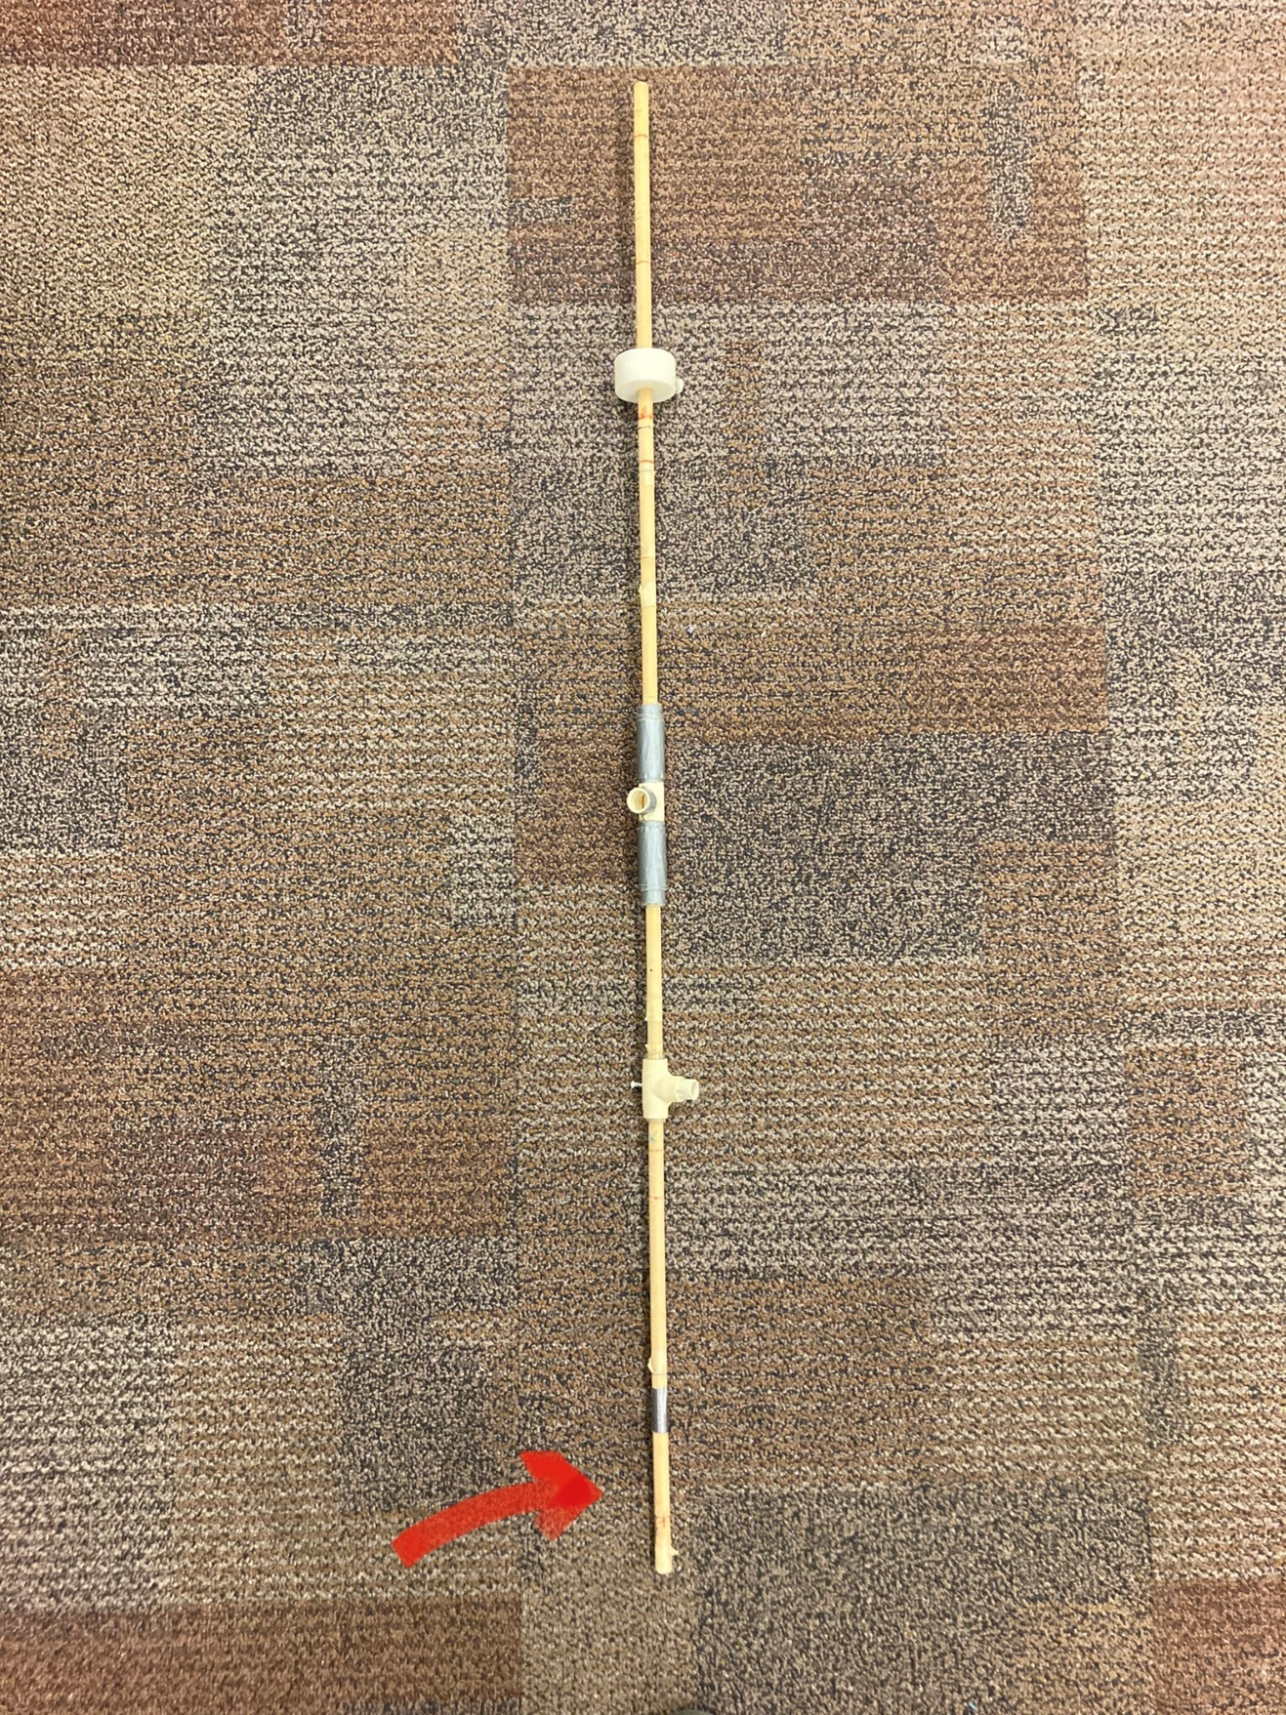
The experimental rod was the same, but the position of the mass was manipulated to change the moment of inertia of the rod.
- Question 1: establishing rod characteristics:
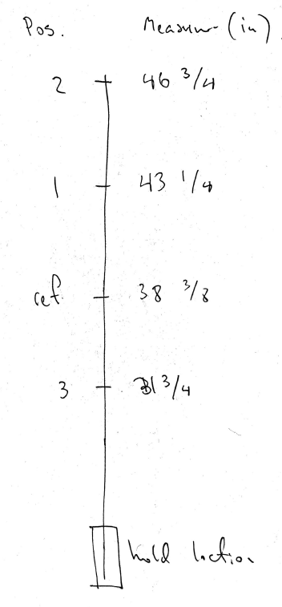
Calculate the Moment of Inertia (“rotational inertia” for each position). The mass of 75 g was positioned in one of the positions: 1, 2, 3, or reference.

I = m*r²
Then you calculate I for each position, make sure to convert m to kg and r to meters.

Experiment 1
Participants judged if the "experimental rod" (weight position column), was lighter/heavier/same as the "reference" rode with the weight positioned in the reference position. The judgment was done by wielding the rod in the right limb - one rod at a time and then making the judgment after exploring the rod.
Working with the hypothesis:
Describe how moving the weight further away from the wrist is likely to change the rotational inertia of the rod in the sagittal plane (front-back):
_________________________________________________________________________________________________
_________________________________________________________________________________________________
_________________________________________________________________________________________________
_________________________________________________________________________________________________
_________________________________________________________________________________________________
When would the rods be perceived to have similar heaviness?
_________________________________________________________________________________________________
_________________________________________________________________________________________________
_________________________________________________________________________________________________
_________________________________________________________________________________________________
_________________________________________________________________________________________________
Results:
Trial | Weight Position | Judgment
1 | ref
2 | 1 | lighter
3 | 2 | lighter
4 | ref
5 | 1 | similar
6 | 2 | lighter
7 | ref
8 | 3 | heavier
9 | 3 | heavier
10 | ref
11 | 1 | heavier
12 | 2 | heavier
Issue - memory component.. Have to remember the reference and it was hard

What would you conclude from these data?
_________________________________________________________________________________________________
_________________________________________________________________________________________________
_________________________________________________________________________________________________

Experiment 2
Participant judged if the "experimental rod" (weight position column), was lighter/heavier/same as the "reference" rode with the weight positioned in the reference position. This time the reference rod was in the left hand, while the comparison rod was in the right. Wielding was done simultaneously in both hands, and the judgment was made at the end of the trial.
Results:
Trial | Weight Position | Judgment
1 | 3 | lighter
2 | 1 | heavier
3 | 2 | lighter
4 | 3 | lighter
5 | ref | similar
6 | 2 | heavier
7 | 1 | heavier

What would you conclude from these data? Is this design better than Experiment 1 – why?
_________________________________________________________________________________________________
_________________________________________________________________________________________________
_________________________________________________________________________________________________

Experiment 3 -torque hypothesis
Participant judged if the "experimental rod" (weight position column), was lighter/heavier/same as the "reference" rode with the weight positioned in the reference position. This time the reference rod was in the left hand, while the comparison rod was in the right. However, this time the participant was not allowed to wield the rod; the judgment was done statically.
Trial | Weight position | Judgement
1 | ref | lighter
2 | 1 | lighter
3 | 2 | heavier
4 | 1 | same
5 | 3 | lighter

What would you conclude from these data? Were there any issues with this design for judging heaviness?

